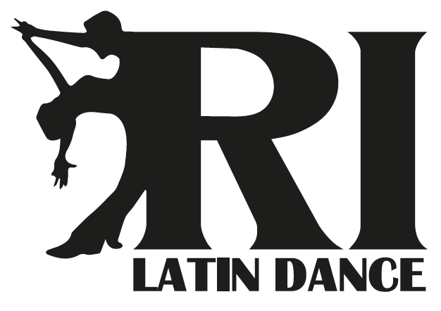
Informed Consent and Liability Waiver for Participation in RI Latin Dance Classes, Workshops, Lessons and Activities.

I agree and consent to the following:

I am voluntarily participating in the RI Latin Dance Classes, Workshops, Lessons, and Activities conducted by an instructor of RI Latin Dance at Club Juventude Lusitana. I recognize that the class requires physical exertion that may be strenuous at times and may cause physical injury and I am fully aware of the risks and hazards involved. I understand that it is my responsibility to consult with a physician prior to and regarding my participation in the above-mentioned program. I represent and warrant that I have no medical condition that would prevent my participation. I agree to assume full responsibility for any risks, injuries or damage know or unknown which I might incur as a result of participating in this class. I knowingly, voluntarily and expressly waive any claim I may have against any instructor, RI Latin Dance or Club Juventude Lusitana for injury or damages that I may sustain as a result of participating in the class. I have read the above waiver and release of liability and fully understand it contents. I voluntarily agree to the terms and conditions stated above.

Print Name: __________________________ Signature: ___________________________ Date: _____________

Photo and Video Release Form

By signing this release form, I authorize RI Latin Dance, to use the following personal
information:

(1) My picture – including photographic, motion picture, and electronic (video) images.

(2) My voice – including sound and video recordings.

I hereby grant to RI Latin Dance, the right to use, publish, and reproduce, for all purposes, pictures of me in film or electronic (video) form, sound and video recordings of my voice, and printed and electronic copy of the information described in sections (1) and (2) above in any and all media including, without limitation, advertising, promotion and the Internet use and educational meetings.

This permission shall continue forever unless I revoke the permission in writing.

I hereby waive the right to receive any payment for signing this release and waive the right to receive any payment for RI Latin Dance use of any of the material described above for any of the purposes authorized by this release.

I acknowledge that I have read the foregoing and I fully understand the contents.

I Authorize the use of video, photos, sound recordings

I DO Not Authorize the use of video, photos, sound recordings

Signature: _____________________________

Date: _________________

